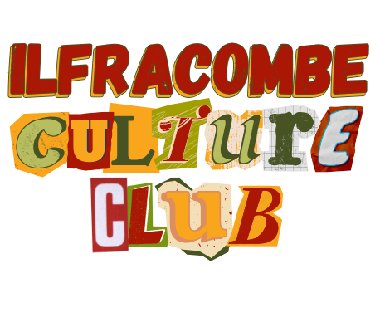
Culture Team Agenda – Monday 9th Feb 2026
Location: Lantern Club Room (Upstairs)
Time: 5pm

- Introductions and Apologies.
- Responses/Actions from the previous meeting
Culture Club Branding for Public Events - Action: Charmain to investigate other best practice examples.
Failed Arts Council Bid - Action: Charmain to speak to North Devon+ to see if we can share the application with the wider Culture Club
Potential Graffiti Space behind Spoons - Action: Mel to follow up with French Marie
Museum of the Homelessness - Action: Charmain to feed this back to the Poverty Truth Commission who have an objective of sharing the story/improving awareness of poverty
Photography Festival - Action: Charmain to confirm that One Ilfracombe can support the application and then confirm with Steve ASAP.
Collective Funding application - Action: Charmain to email wider Culture Club members to establish funding needs for specific projects.

- Photography Festival - Steve Gear
- UK Town of Culture 2028 Bid
- Funding Updates/Opportunities
- Ideas from the Table
- AOB

